Python Assignment 2
Data Structures - List, Dictionary, Set & Conditional Statements
List (Creation, Modification and Access)
- List Creation
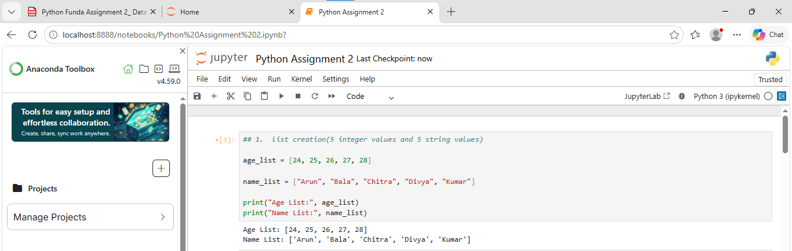

- List Operations / Modifications
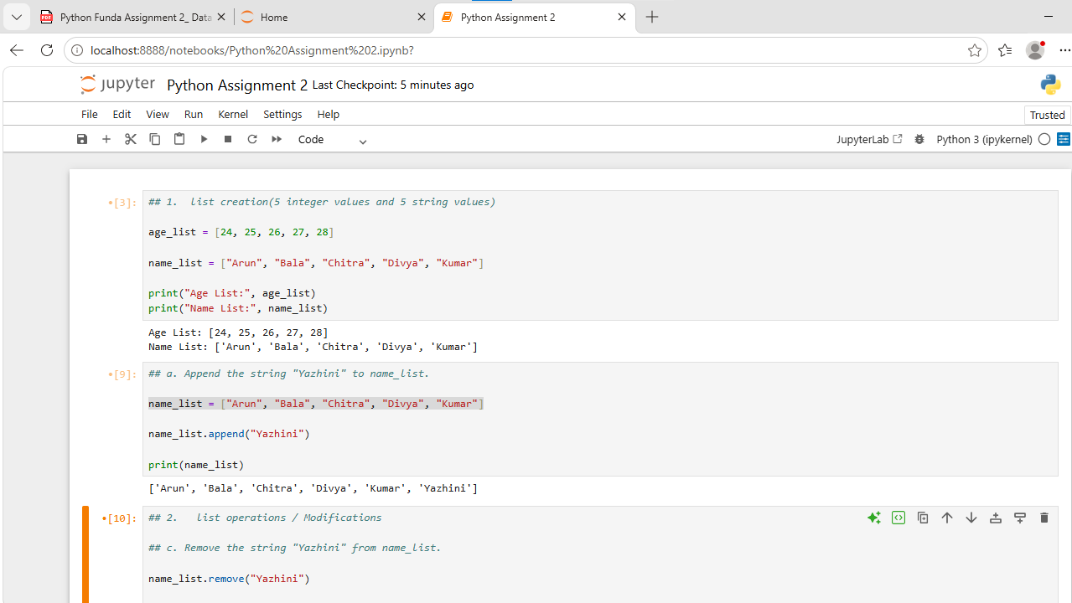

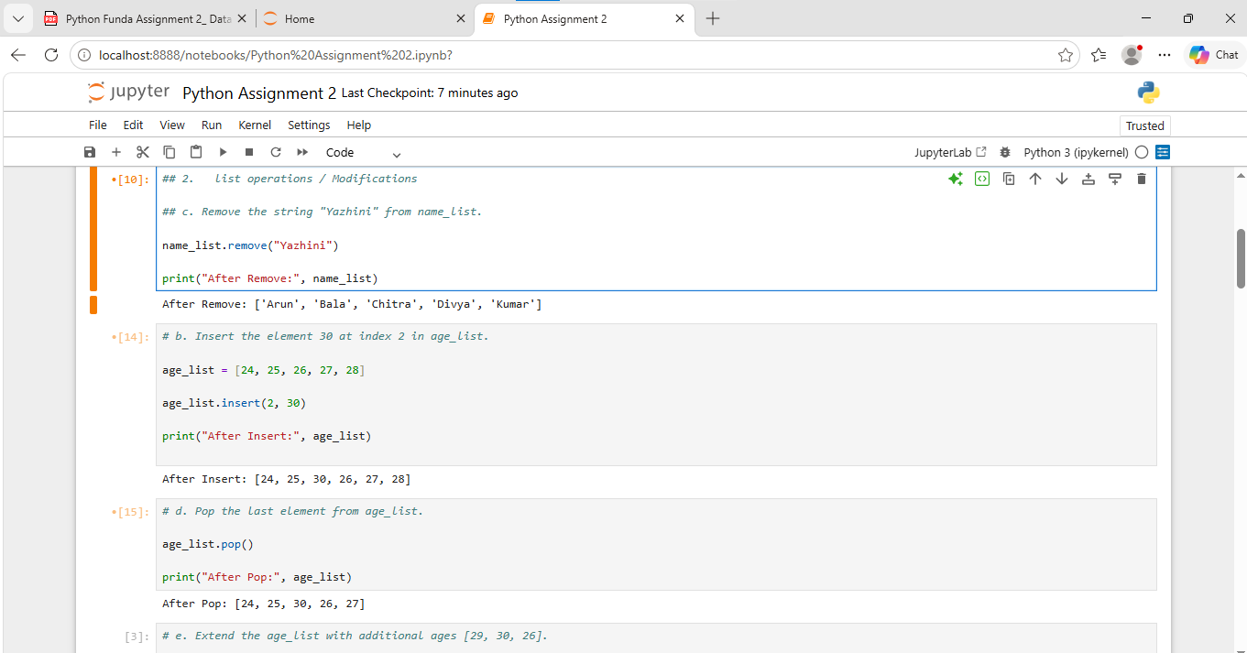

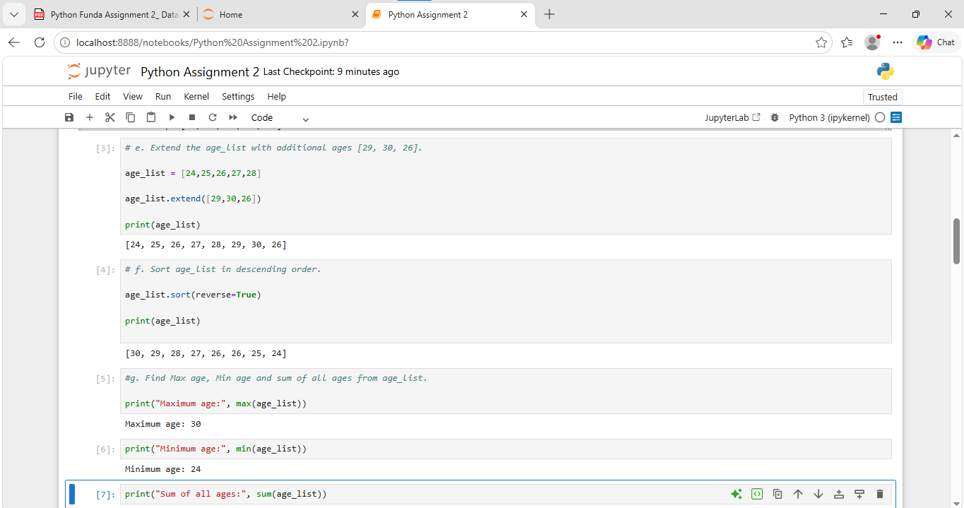

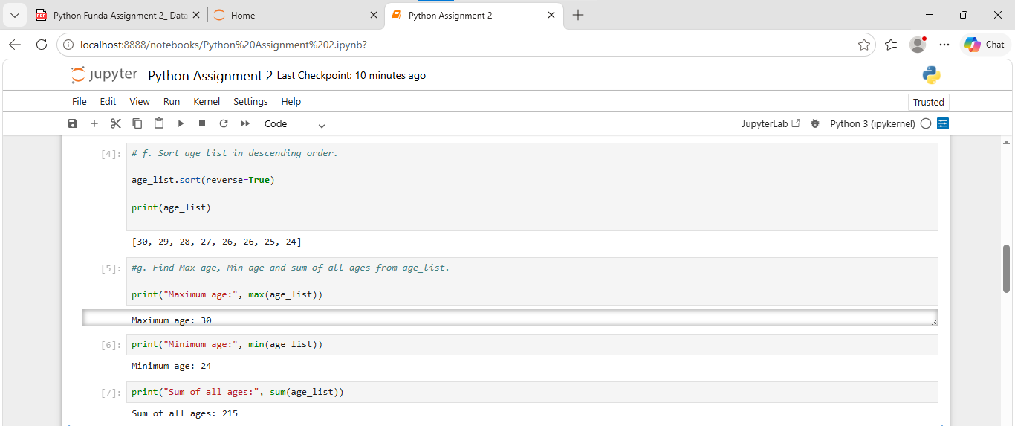
- Accessing List Elements
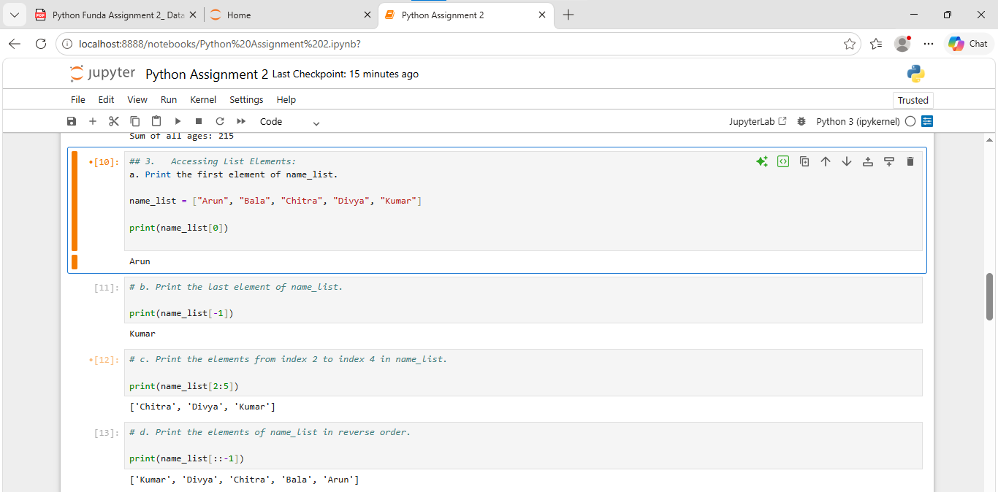

Dictionary (Creation, Modification and Access)
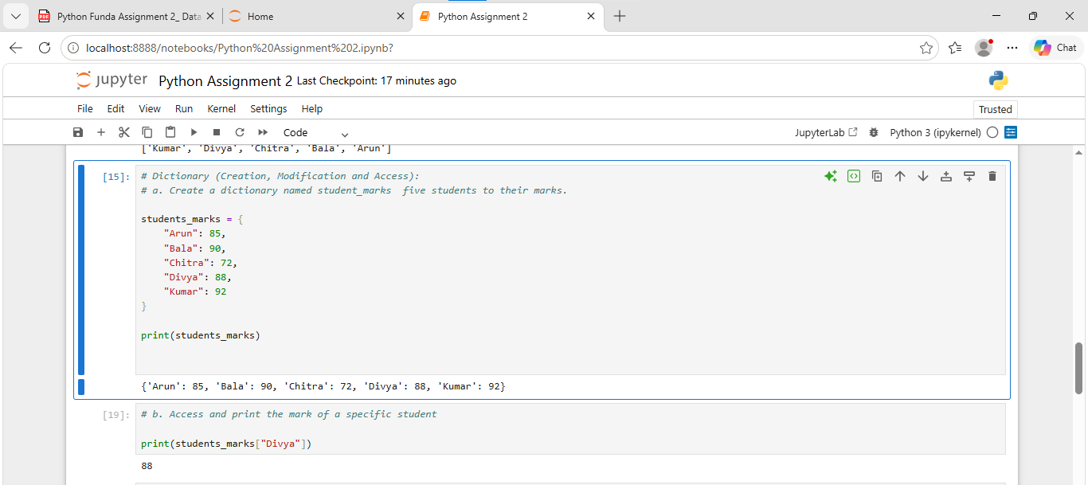
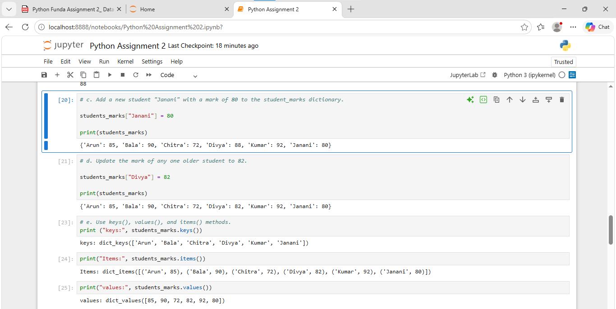
Sets (Operations)
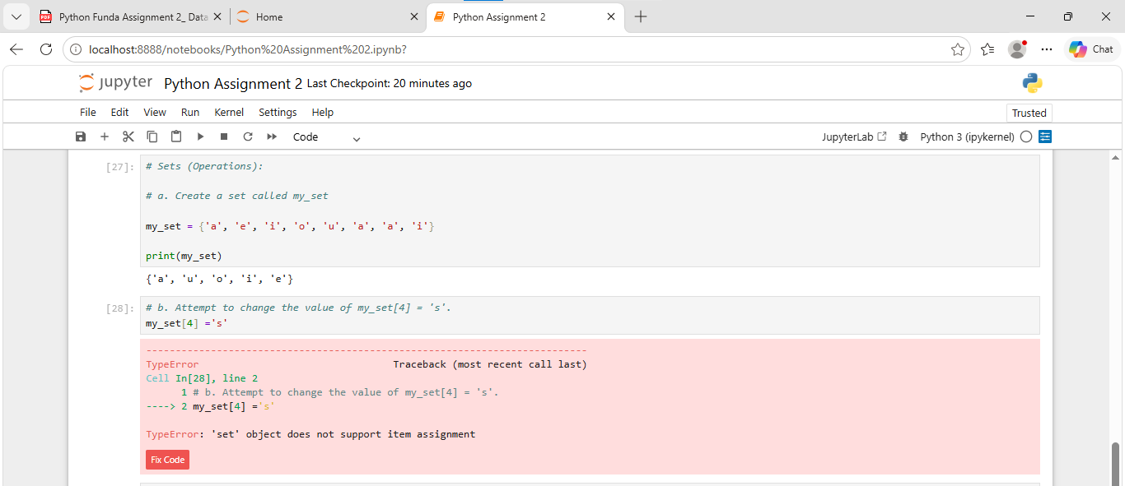
Notes
Python sets are unordered and do not support indexing or item assignment. Therefore, we cannot change an element using an index.
- Set is unordered, unique value
- It remove duplicates

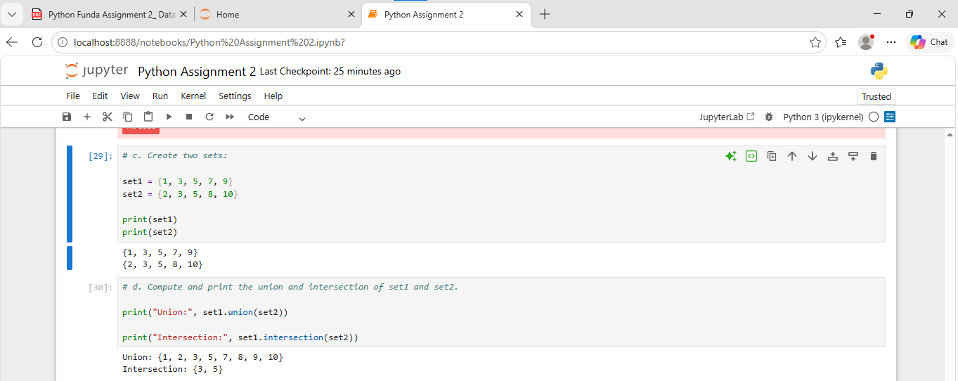
Operators & Conditional Statements
(IF, ELIF, ELSE)
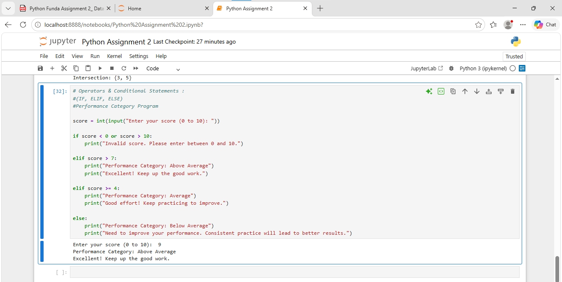

Conclusion
In this assignment, I learned the basic concepts of Python, including Lists, Dictionaries, Sets, Operators, and Conditional Statements. I practiced creating, accessing, modifying, and performing operations on different data structures. I also learned how to use IF, ELIF, and ELSE statements to make decisions based on conditions.

